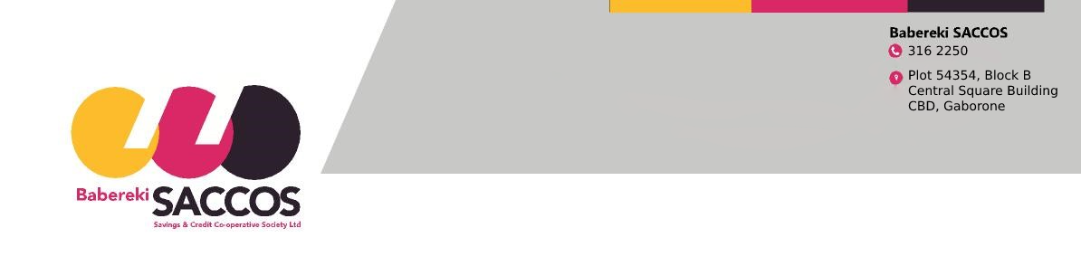

MEMBERS DIRECT DEBIT ORDER AUTHORIZATION FORM

I ……………………………………………………..of Omang number …………………………………………………
authorise Babereki Savings and Credit Cooperative Society to deduct payments for my obligations due to it. The reason you may not deduct directly from salary is
because:

……………………………………………………………………………………………………………………………….

Details of my bank account

Bank name: …………………………………………......... Branch: …………………………………………………......

Branch Code: …………………………… Account number: …………………………………………………………….

Effective date of deduction: …………………………………………………………………………………………….....

Monthly date of deduction: …………………………………………………………………………………………………

Period of deduction from: ……………………………………….. to: …………………………………………………….

Payment for: Membership fee: P………………………..

Monthly Savings: P ……………………….

SACCOS Shares: P ………………………

Other (specify) ………………… P……………………….

Total Amount Deduction P………………………

Salary date of payment ……………………………….. Please Tick Group 1 Group 2

Previously employed by: Ministry ……………………………………… Department …………………………………

Current employer : …………………………………………………………………………………………………………

Current Adress: ……………………………………………………………………………………………………….......

Telephone: Work …………………………….. Home: ……………………….. Cell: ……………………………….....

Singned by member …………………………………………… Date: …………………………………………………

FOR HEAD OFFICE USE (BABEREKI SAVINGS AND CREDIT COPERATIVE SOCIETY)

COMMENTS: ……………………………………………………………………………………………………...

CHECKED BY: ……………………………………………………………………………………………………

SIGNATURE: ……………………………………………………. DATE: ……………………………………..

